Section One: Accessing the Call Management System
To access the call management system, first ensure that you are connected to the CIS network. Specifically, make sure you can access 10.25.1.X network commonly associated with VMs. From there, enter 10.25.1.69 in the address bar. This will bring up the FreePBX homepage. You should see the following:

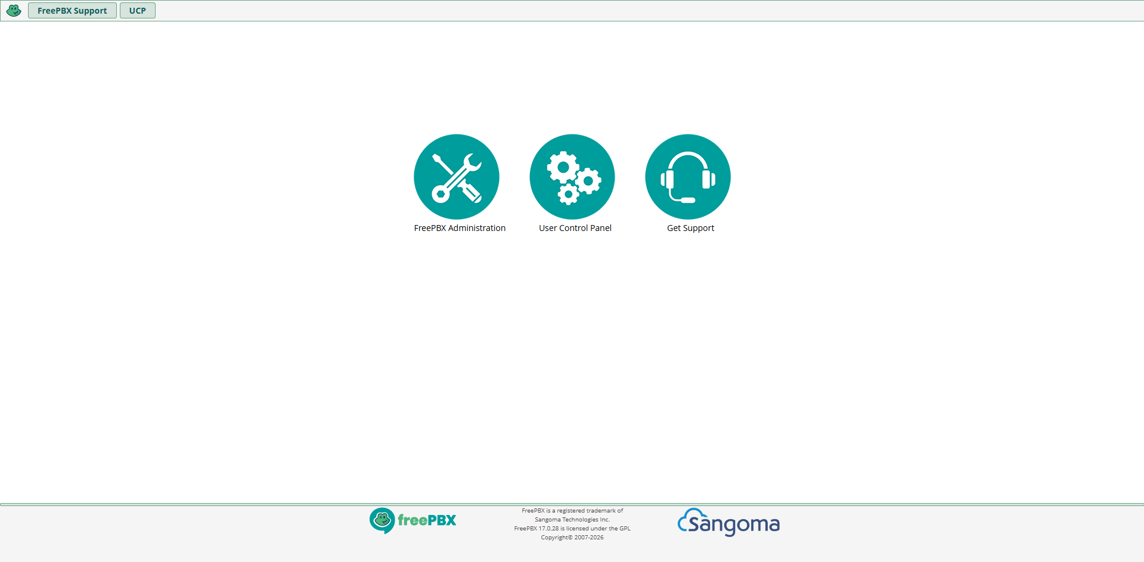

Now, select FreePBX Administration. You will be prompted to enter a username and password. Enter the following:
Username: 351_VoIP
Password: Rajah424!
This will bring you to the dashboard, which will look like the following:
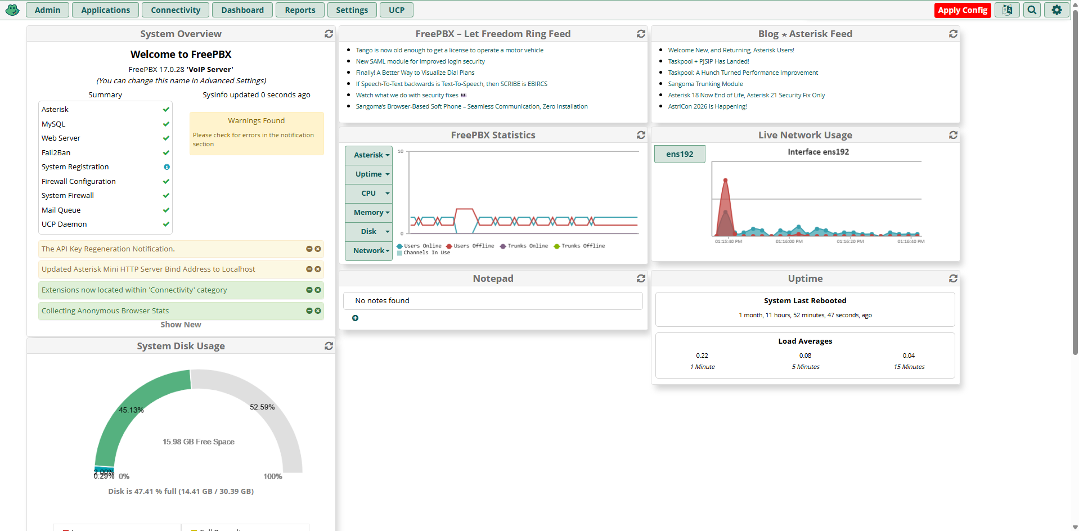
Section Two: Accessing Call Logs
To access call logs, first access the dashboard. To access the dashboard, refer to section one. From the dashboard, notice the menus at the top of the screen. Notice the menu labeled “Reports”. Click on “Reports”. From the dropdown menu, select “Call Event Logging”. You will see a screen similar to the following:
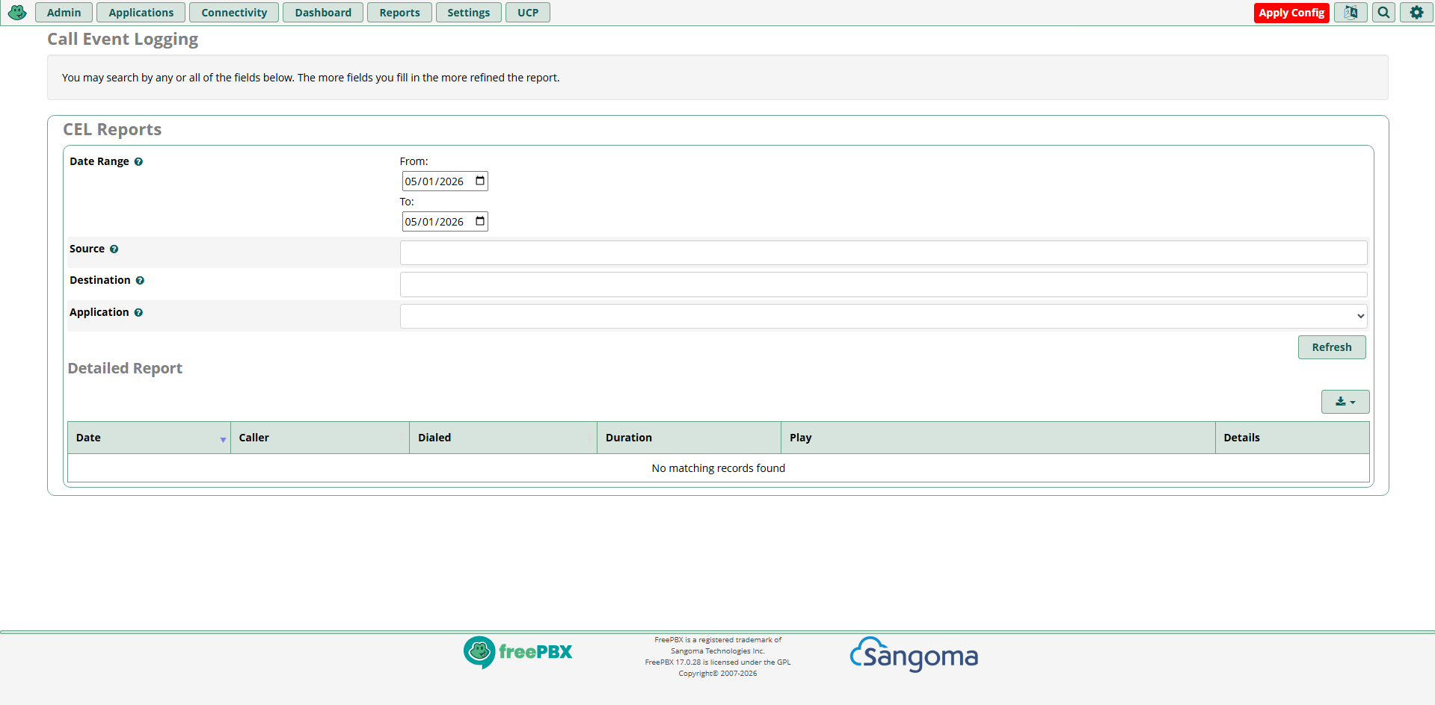
To view logs, select a date range and you will be shown simple logs for those dates. More complicated logs are available with a payment.

Section Three: Adding New Phones
To add new phones, first access the dashboard. To access the dashboard, refer to section one. From the dashboard, notice the menus at the top of the screen. Notice the menu labeled “Connectivity”. Click on “Connectivity”. From the dropdown menu, select “Extensions”. You will see a screen similar to the following:
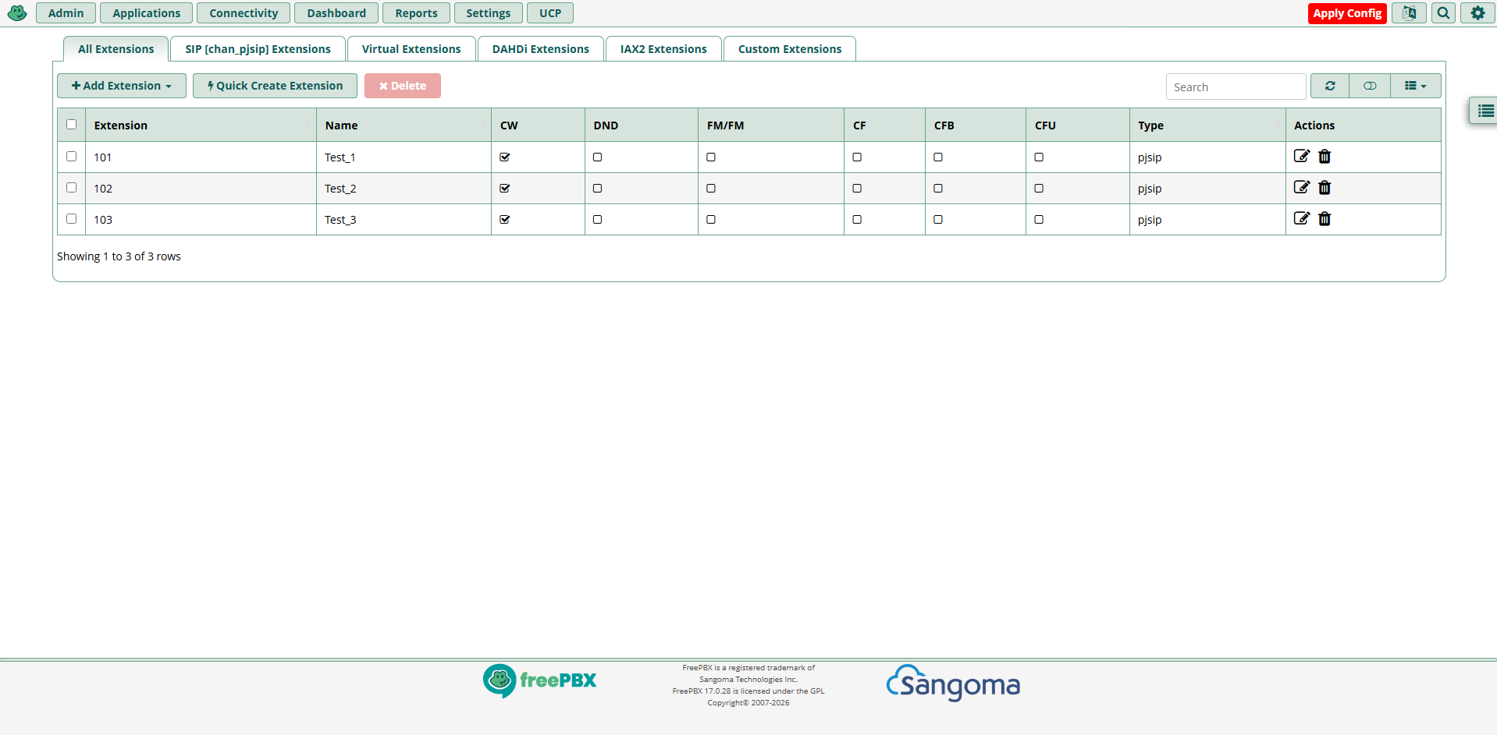
Notice the “Add Extension” menu. Select the “Add Extension” menu. From the dropdown, select “Add New SIP [chan_pjsip] Extension”. You will see a screen similar to the following:
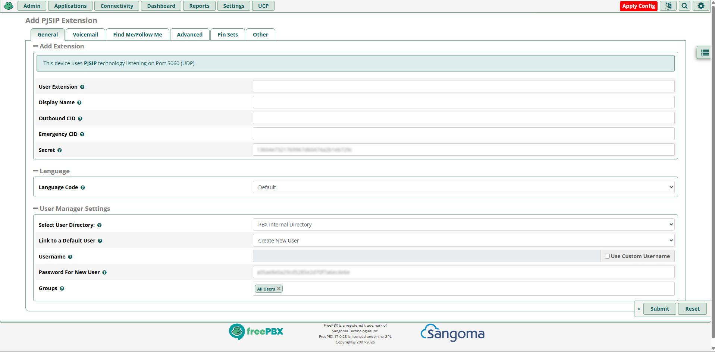
Fill out the following fields: User Extension, and Display name. Make no other changes.
Now, open a new tab in the browser. Ensure that the phone is connected to the network, and locate the IP address for the phone. In our case, pressing the “Next Page” button on the phone’s home screen will display the IP address. You should see something similar to the following:
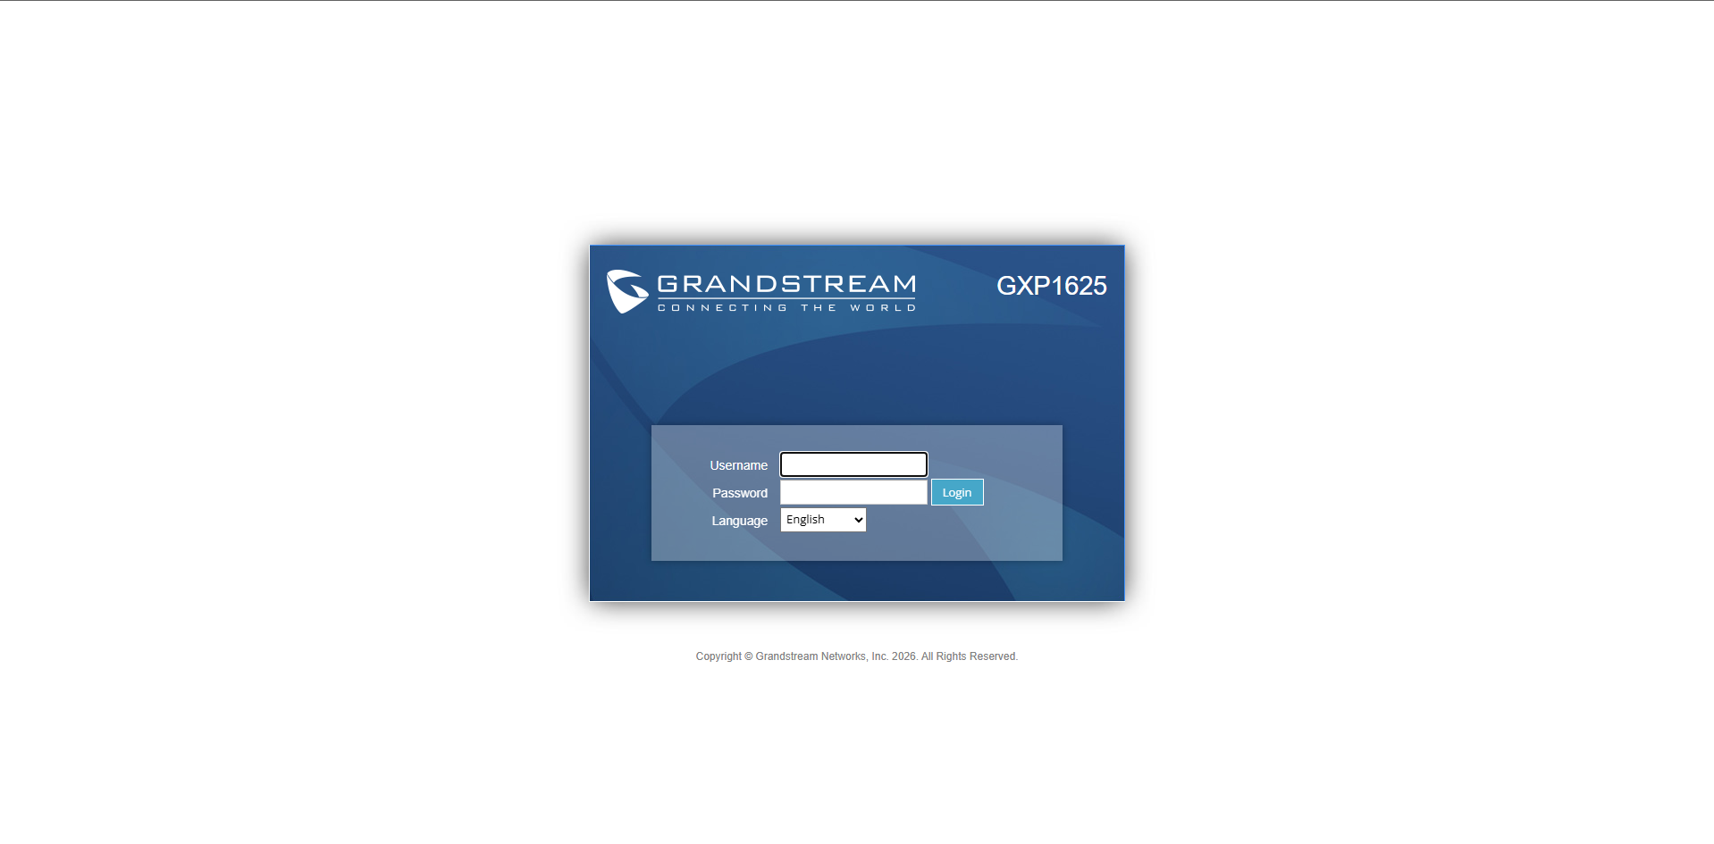

From here, enter the admin user and password for the phone. This is often found in the manual. For the phones we already set up, use the following:
Username: admin
Password: Rajah424!

You will then see a screen similar to this:
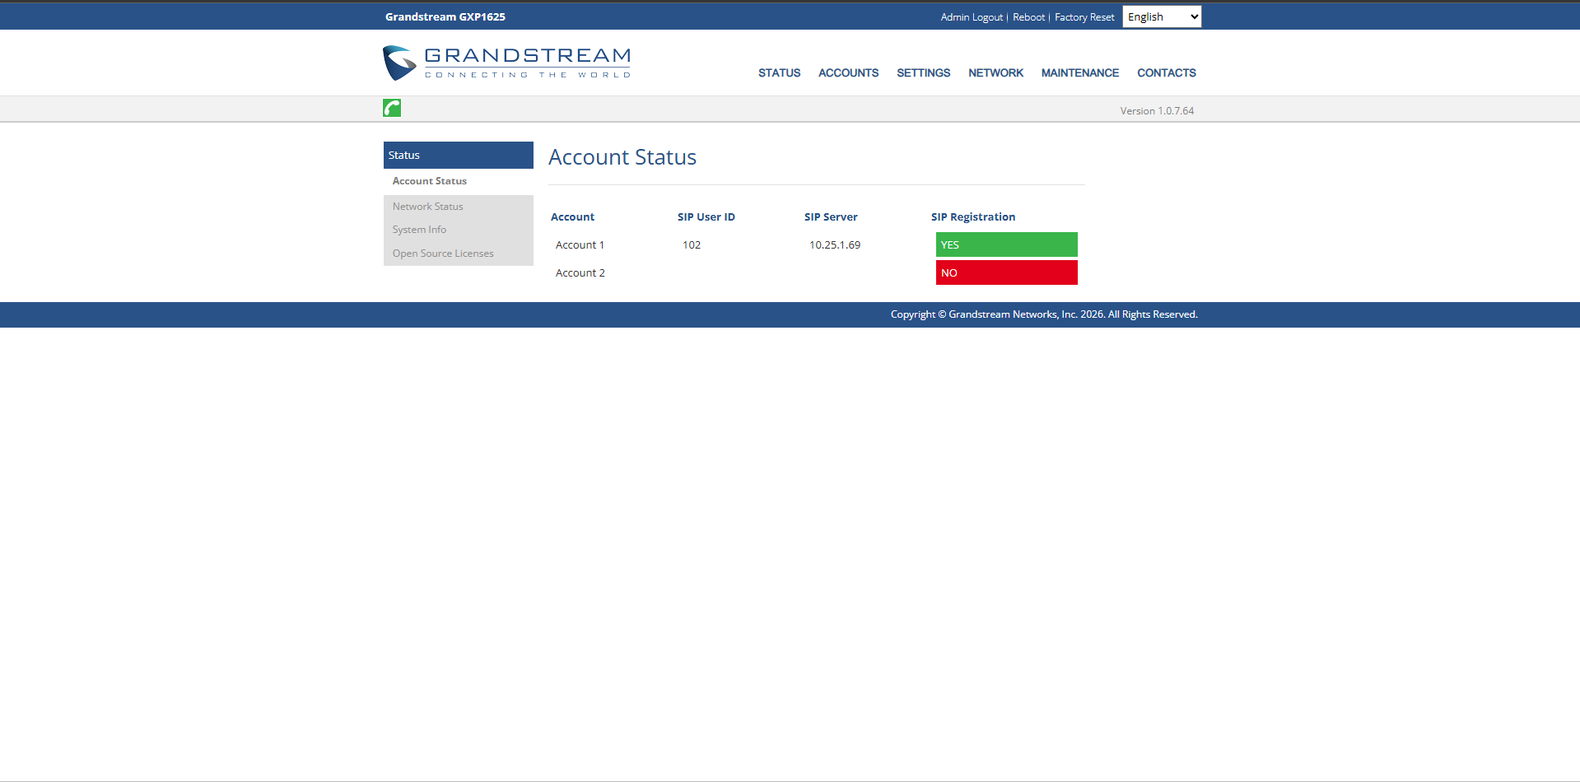
From here, navigate to the accounts menu, and to Account 1>General Settings from the dropdown. You should see something similar to the following:

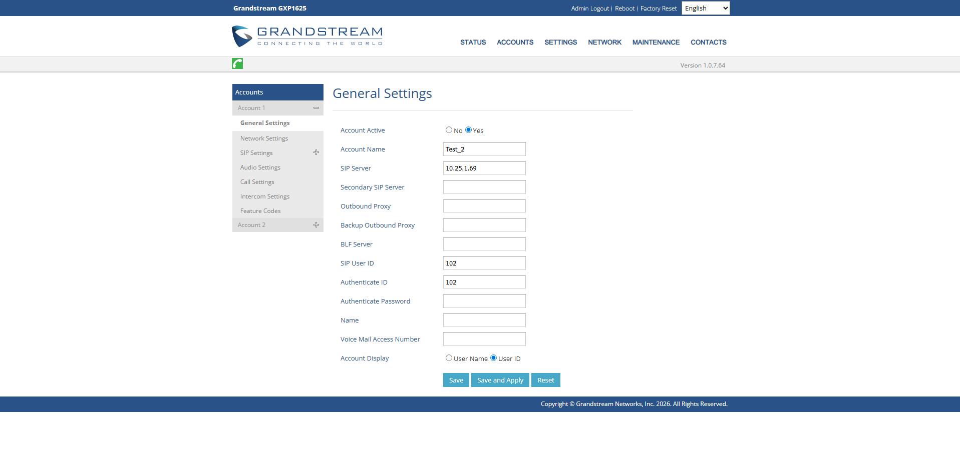

Fill out the following fields:
Account Name: (What was entered in the “Display Name” field)
SIP Server: 10.25.1.69
SIP User ID: (What was entered earlier in the “User Extension” field)
Authenticate ID: (What was entered earlier in the “User Extentsion” field)
Authenticate Password: (The value located in the “Secret” field)
Ensure account active is toggled to “Yes” and User ID is being used for account display. Select “Save and Apply”. Then navigate back to the account status page. From here, navigate back to the FreePBX page. Press “Submit” and then make sure to select “Apply Config”. Now, restart the phone so that it updates.
Wait until the SIP Registration turns green on the phone’s Account Status page. This may take several minutes.

